OS Assigment-5 | SimpleMultiThreader: Using MultiThreader with Ease
Group ID-16
Members: Vaibhav Samrat Waghaye | 2024597, Rigzin Gyalpo | 2024458
Contributions:
Vaibhav-> parallel_for functions, struct Thread
Rigzin-> parallel_for functions, runTask
Implementation:
Our program creates a lightweight parallel-execution system using POSIX threads and demonstrates how the lambda functions are captured, stored, and then executed. There are two thread-data structures, ThreadData1 for 1D loops and ThreadData2 for 2D loops, each of which contains the particular iteration ranges that each thread should process along with the lambda to be executed.
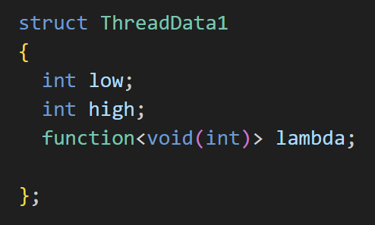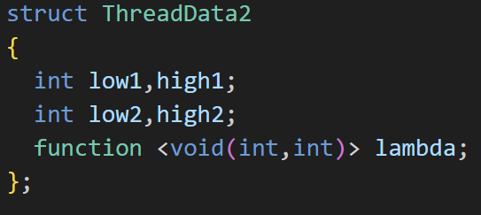
The worker functions runTask1 and runTask2 are the thread entry points, and they simply loop over the assigned indices and invoke the stored lambda for each iteration. The overloaded parallel_for functions divide the total work into approximately equal chunks, accounting for leftover iterations, and assign each chunk to a separate thread with pthread_create; then they wait for all the threads to finish with pthread_join and print the execution time measured by std::chrono.
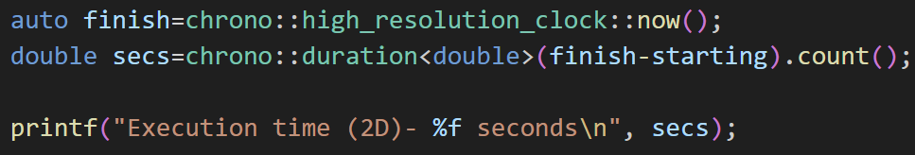
This demonstrational function gives a very minimal example of how an r-value reference to a lambda can be forwarded and invoked. In main, example lambdas are created with specific capture rules, one capturing the variables by value and reference to print out a welcome message, and another capturing nothing, printing out a closing line, and both are executed via demonstration.
The program first invokes user_main, which is where the student's actual assignment code goes. Finally, the #define main user_main macro ensures that the student's own main function is internally renamed, so the framework's main can run first and handle the flow of the program.
Test Cases:

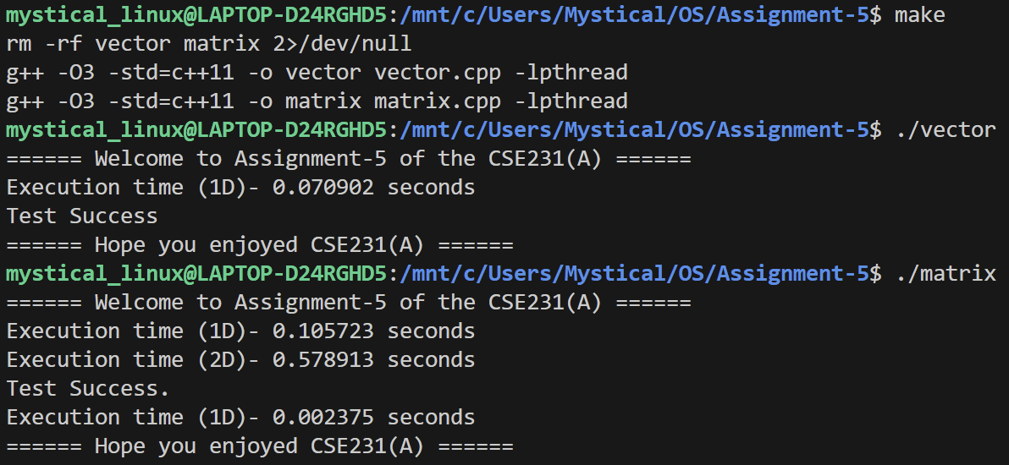

Github- https://github.com/vaibhavsw27/group-16-A5

